Project Report

for

Cinema E-Booking System

Version 1.0 approved

Prepared by Tripp Guinn

Karolina Sabonaityte

Daniel Pacheco

Hayden Behre

CSCI 4050 Section B

November 27, 2018

# Introduction

This project report describes the software functional and nonfunctional requirements, system design, user interface design, data model, and software testing of the Cinema E-Booking System (CES). This document is intended to be used by the members of the project team that will implement and verify the correct functioning of the system.

The purpose of the Cinema E-Booking System is to ease booking management and to create a convenient and easy-to-use application for users, trying to buy movie tickets. The system is based on a relational database with its booking management and reservation functions. We will have a database server supporting several recently released movies that get updated weekly. Above all, we hope to provide a comfortable user experience along with the best pricing available.

# Functional Requirements

* User should be able to register for an account
* User should be able to login and logout
* User should be able to book a ticket
* User should be able to apply a promotional code
* User should be able to view order history
* User should be able to view and modify profile
* User should have the option to receive password in email if the password is forgotten
* User should be able to subscribe and unsubscribe to promotions
* User should have the option to browse and search movies
* User should have the option to receive a refund if a ticket is returned at least 60 minutes before the start of the movie showing
* Administrator should be able to add and remove a promotional code
* Administrator should be able to change a ticket cost
* Administrator should be able to add, update, or delete a movie
* Administrator should be able to add, update, or delete an employee

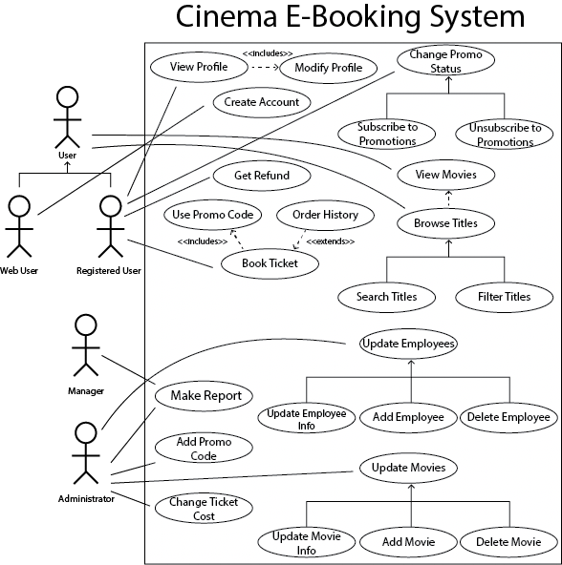

# Non-Functional Requirements

* The system should have the user guild of the system and cannot allow complex interface design
* The system should have a good response time in which it needs to respond in the shortest time after customer clicks a button
* The system should be able to perform in different platforms such as Linux, Windows, and Mac OS
* The system should store customers in the database and not review any information without agreement of the particular customer
* The system should be able to perform in any type of web browser such as Windows Explorer, Mozilla Firefox, Google Chrome, etc.
* The system should be updated on a weekly basis as new movies are released

# System Design

The project is structured as a Model View Controller. The model is represented using java classes. These java classes represent the data. The view is represented using HTML. This displays the model data as a web page that the user interacts with. The view sends user actions such as button clicks and navigation to the controller. The controller is represented using Java and CSS. It provides model data to the view and interprets user actions such as button clicks.

# User Interface Design

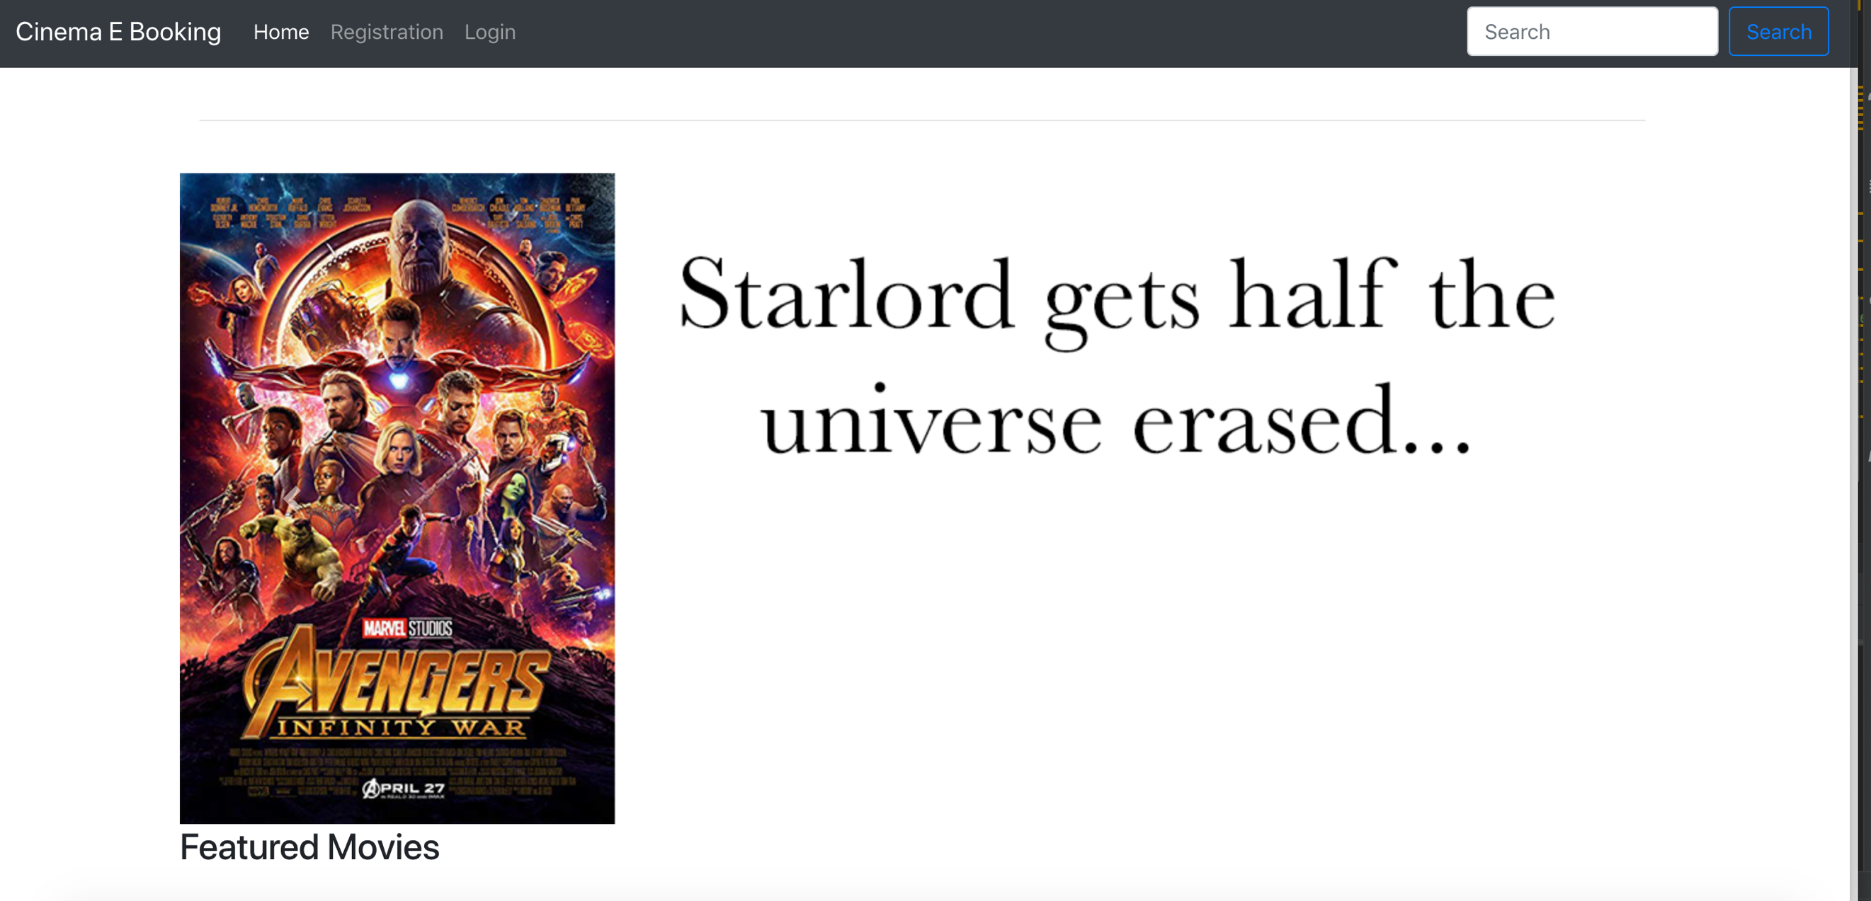

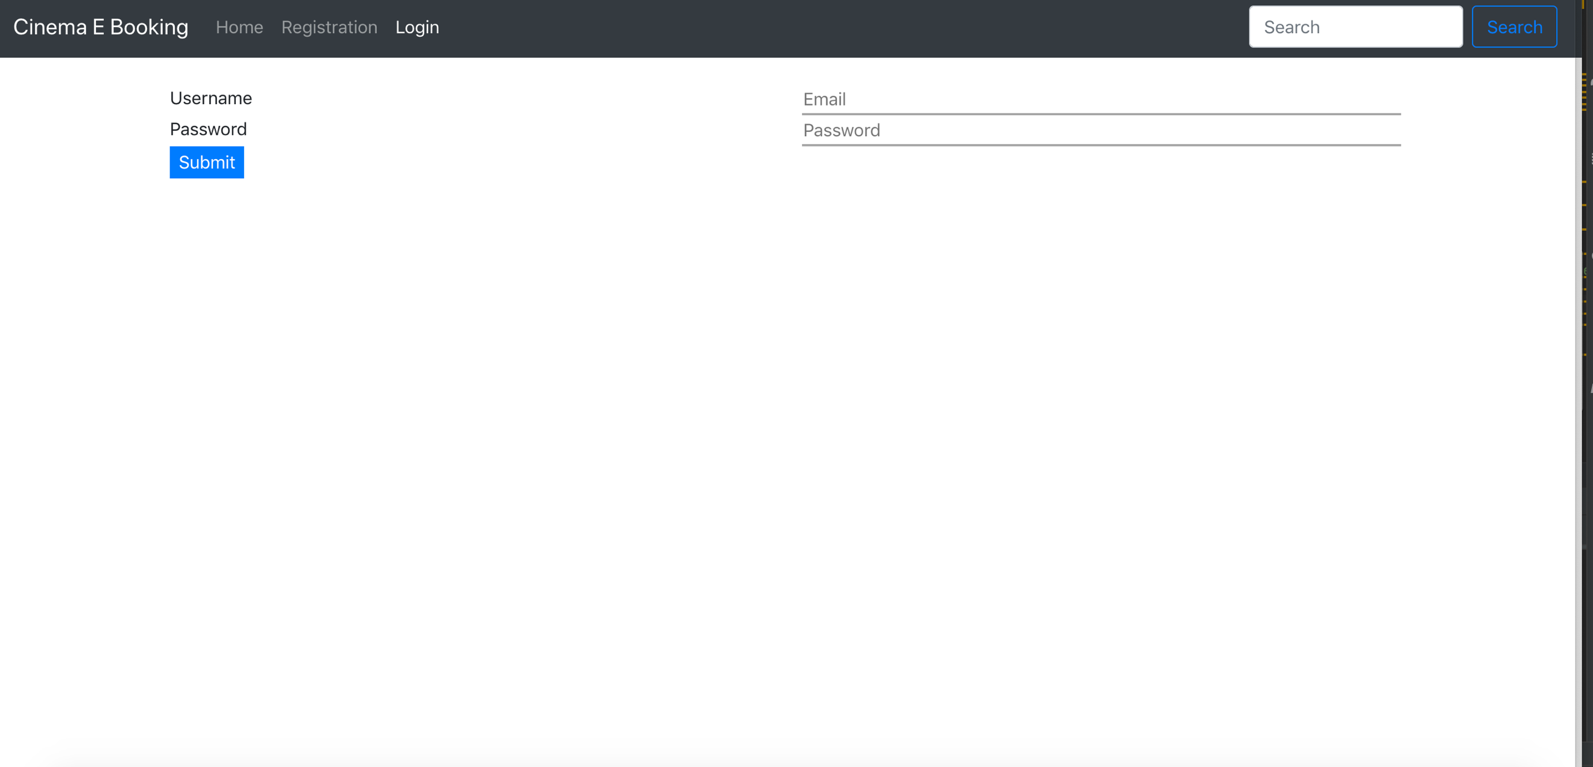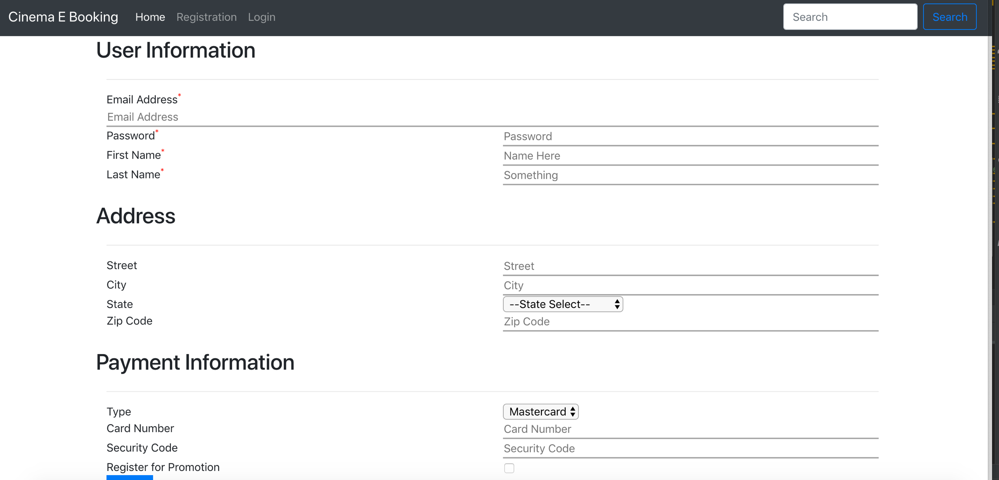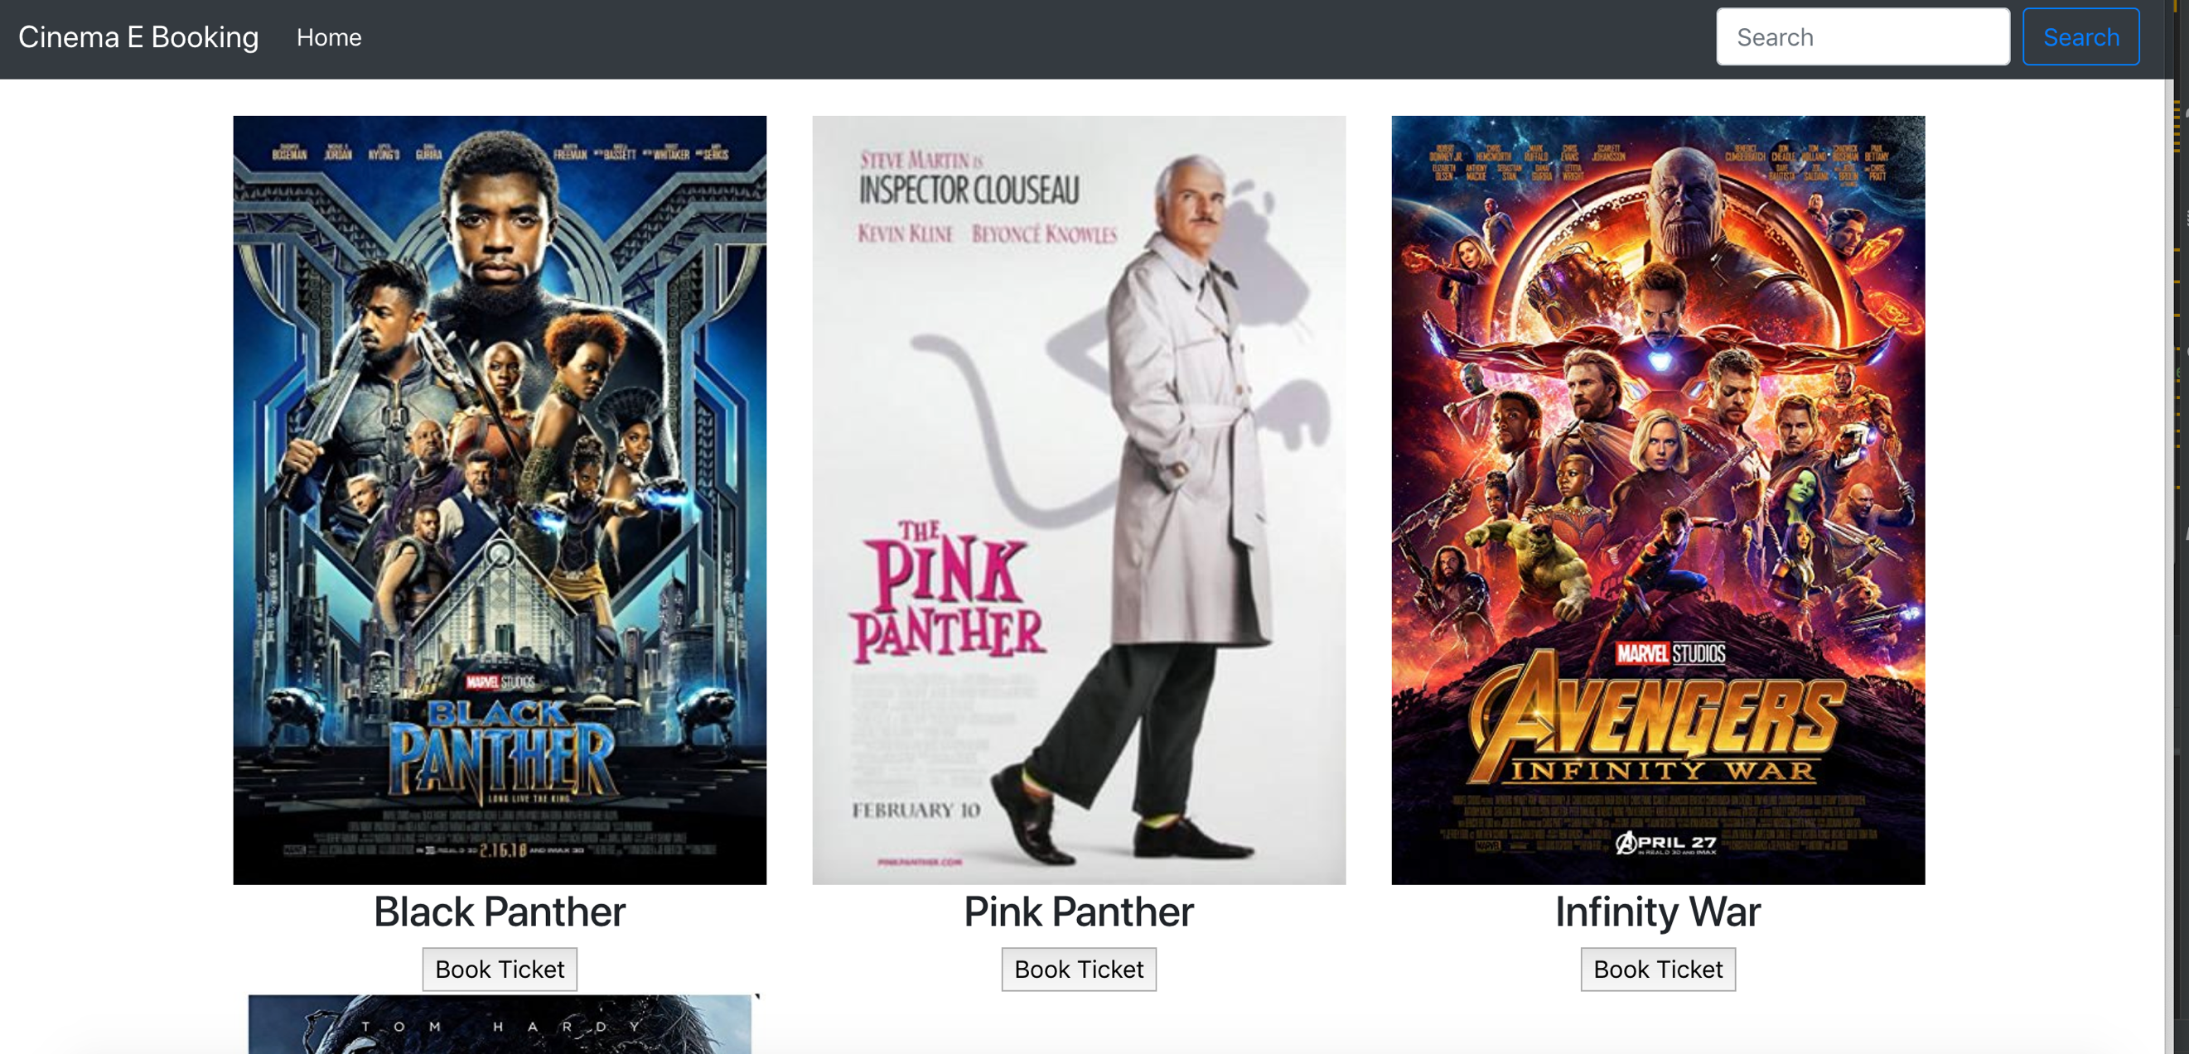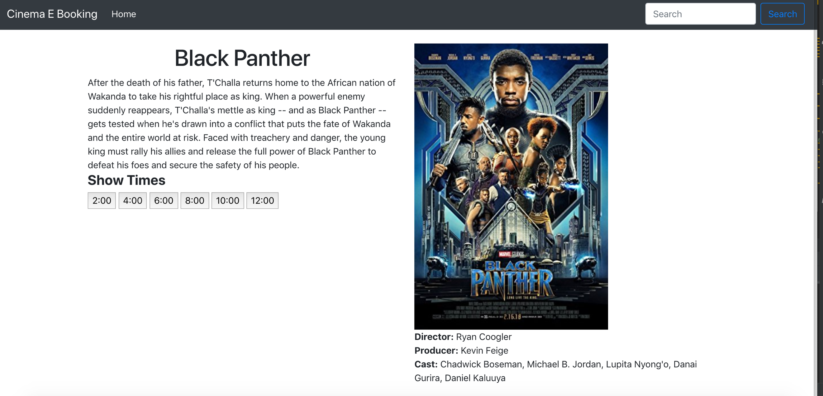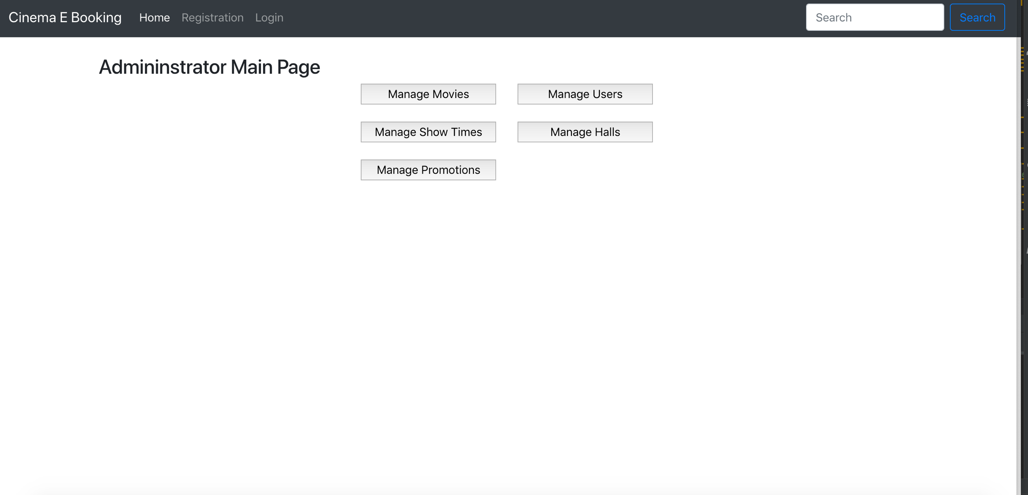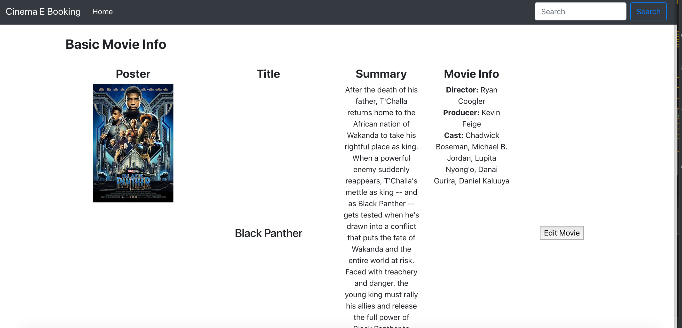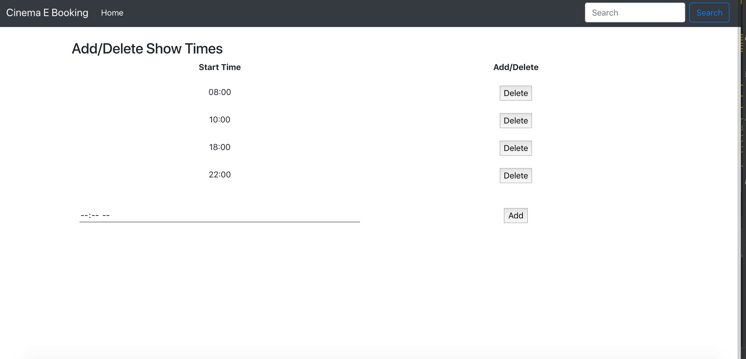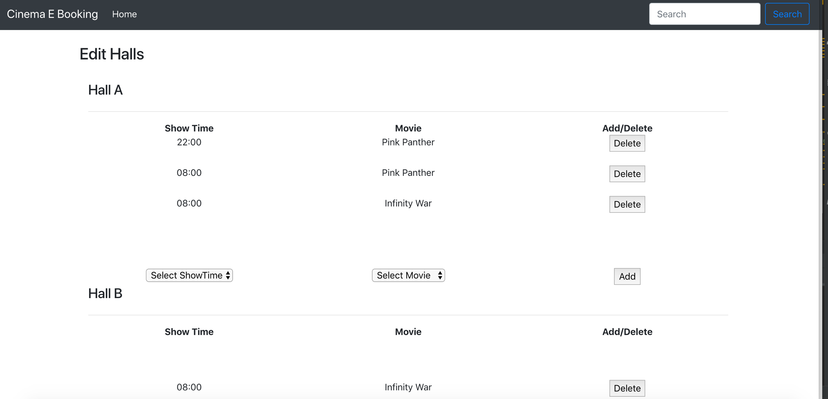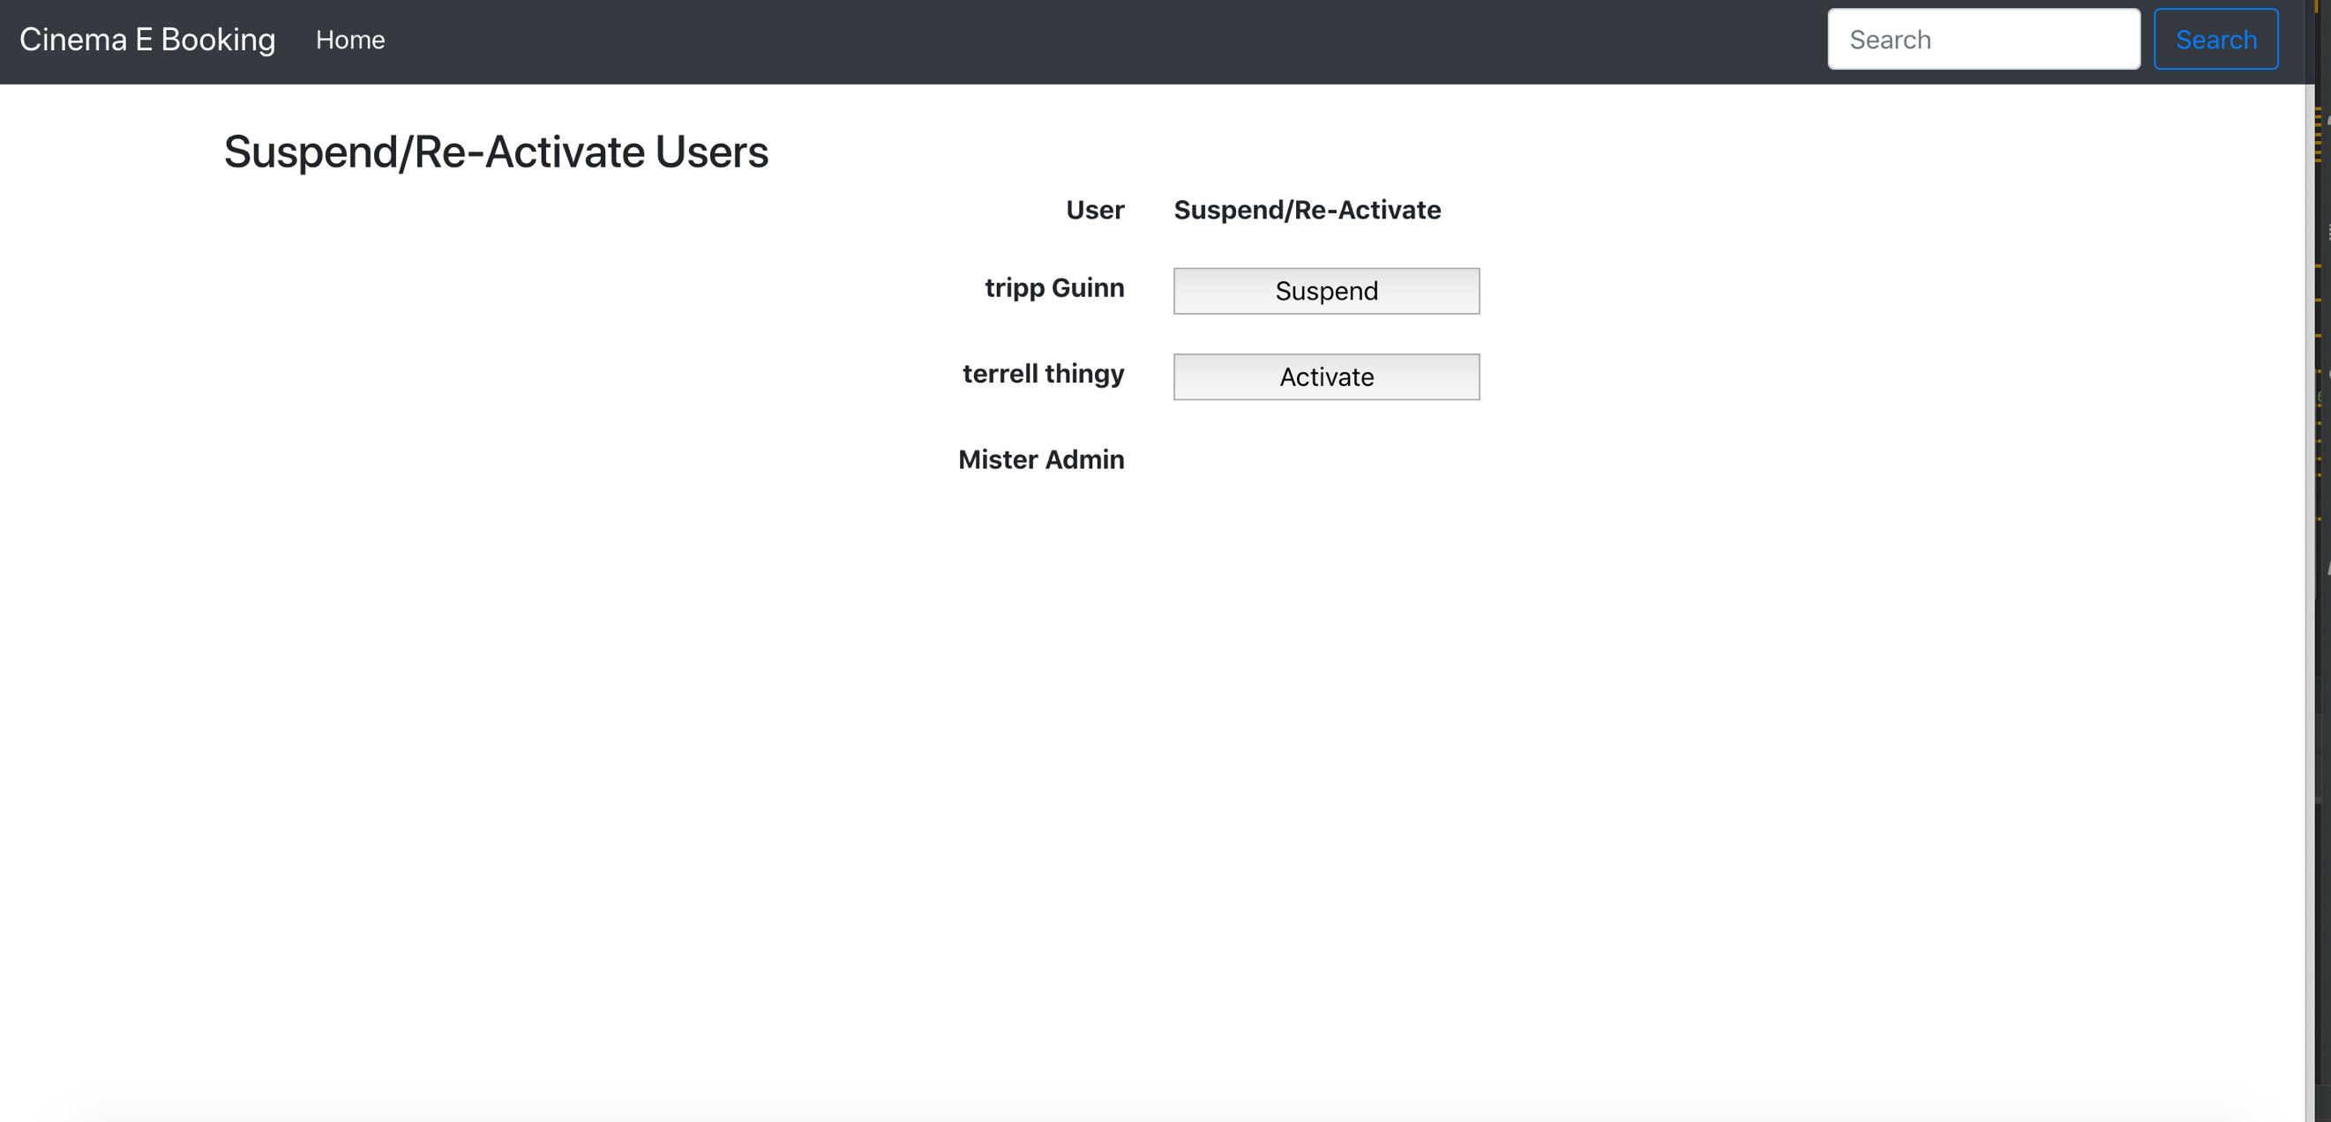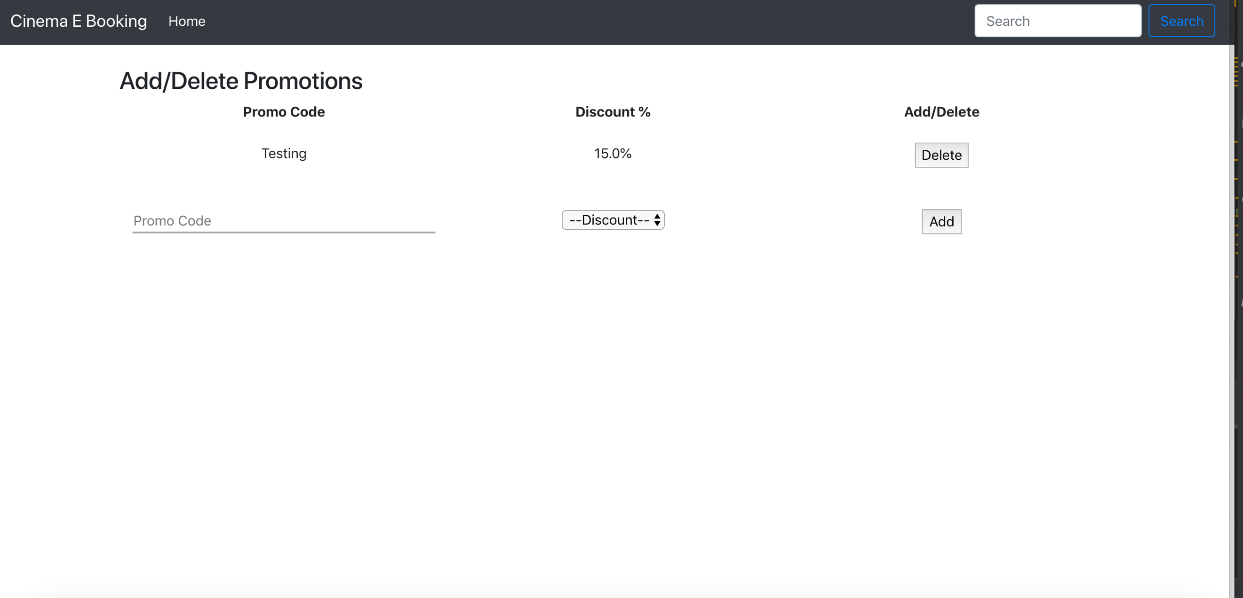

# Data Model

The major features of booking database system as shown in below entity-relationship model

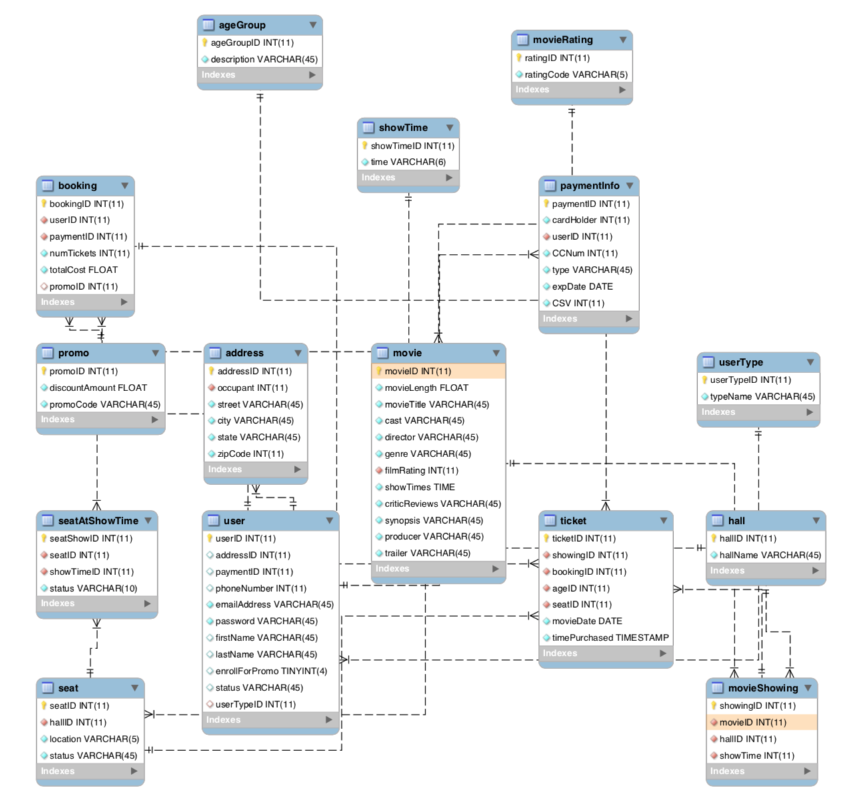

# Software Testing

|  |  |  |  |  |  |  |
| --- | --- | --- | --- | --- | --- | --- |
| **Test Case ID** | **Test Scenario** | **Test Steps** | **Test Data** | **Expected Results** | **Actual Results** | **Pass/Fail** |
| TU01 | Check customer login with valid data | 1. Go to site 2. Enter UserID 3. Enter Password 4. Click Submit | UserID = guru99  Password = pass99 | User should Login into application | As Expected | Pass |
| TU02 | Check customer login with invalid data | 1. Go to site 2. Enter UserID 3. Enter Password 4. Click Submit | UserID = guru99  Password = glass99 | User should not Login into application | As Expected | Pass |
| TU03 | Check customer registration with valid data | 1. Go to site 2. Enter Register User 3. Input Data 4. Click Submit | Email = sarah@uga.edu  Password = pass99 | User should Register in the System | As Expected | Pass |
| TU04 | Check customer registration with invalid data | 1. Go to site 2. Enter Register User 3. Input Data 4. Click Submit | Email = something.incorrect  Password = pass99 | User should not Register in the System | As Expected | Pass |
| TU05 | Book a ticket without selecting a seat | 1. Go to site 2. Customer Login 3. Select a Movie 4. Book a Ticket |  | Display error message “Please select a seat.” | As Expected | Pass |
| TU06 | Book more than 5 tickets | 1. Go to site 2. Customer Login 3. Select a Movie 4. Book a Ticket |  | Display error message “You cannot book more than 5 tickets per session.” | As Expected | Pass |
| TU07 | Book an unavailable seat | 1. Go to site 2. Customer Login 3. Select a Movie 4. Book a Ticket |  | Unable to Select | As Expected | Pass |
| TU08 | Apply correct Promotional Code | 1. Go to site 2. Customer Login 3. Go to checkout 4. Input Data | Promo = A87RL1B | Promotional code accepted, and discount reflected on ticket | As Expected | Pass |
| TU09 | Apply incorrect Promotional Code | 1. Go to site 2. Customer Login 3. Go to checkout 4. Input Data | Promo = #$*!0)/- | Promotional code rejected, and discount not applied, display “Promotional code is invalid.” | As Expected | Pass |
| TU10 | Refund a Ticket more than 60 min before showtime | 1. Go to site 2. Customer Login 3. View order history 4. Refund Ticket |  | Ticket is returned to system, seat is available, and customer receives money back | As Expected | Pass |
| TU11 | Refund a Ticket after showtime has started | 1. Go to site 2. Customer Login 3. View order history 4. Refund Ticket |  | Displays error message “Cannot refund a ticket after 60 minutes before showtime.” | As Expected | Pass |
| TU12 | Administrator adds a new movie with valid Data | 1. Go to site 2. Administrator Login 3. Add Movie 4. Input Data | Showtime = 11:00 | Movie is added to the list with the valid showtime | As Expected | Pass |
| TU13 | Administrator adds a new movie with invalid Data | 1. Go to site 2. Administrator Login 3. Add Movie 4. Input Data | Showtime = 12345 | Displays error message “Invalid showtime.” | As Expected | Pass |
| TU14 | Check if the user can book a ticket with valid credit card data | 1. Go to site 2. Customer Login 3. Select a Movie 4. Book a Ticket | Credit Card = 1234-5678-1234-5678 | Ticket is purchased, and seat is reserved | As Expected | Pass |
| TU15 | Check if the user can book a ticket with invalid credit card data | 1. Go to site 2. Customer Login 3. Select a Movie 4. Book a Ticket | Credit Card = %Mdfd@773dA1 | Displays error message “Invalid credit card information.” | As Expected | Pass |